

Real World Challenges of Implementing Information Systems in Financial Institution: the Perspective of Bangladesh Development Bank Limited (BDBL)

Term Paper



December 13, 2018

Group 3

BSSE08

**Submitted to**

Dr Mohammed Shafiul Alam Khan

Associate Professor

Institute of Information Technology

University of Dhaka

**Submitted by**

**Group 3**

Tulshi Chandra Das (BSSE0811)

Afia Sajeeda (BSSE832)

Saara Sheneen (BSSE833)

Maloy Kanti Sarker (BSSE834)

Batch BSSE08

Institute of Information Technology

University of Dhaka

Date of Submission: 13/12/18

**LETTER OF TRANSMITTAL**

13-Dec-18

Dr. Mohammed Shafiul Alam Khan

Associate Professor

Institute of Information Technology

University Of Dhaka

Subject: Submission of term paper on ‘Real World Challenges of Implementing Information Systems in Financial Institution: the Perspective of Bangladesh Development Bank Limited (BDBL)’

Dear Sir

With due respect, we are pleased to submit the final report on ‘Real World Challenges of Implementing Information Systems in Financial Institution: the Perspective of Bangladesh Development Bank Limited (BDBL)’. Although this report may have shortcomings we did try our level best to produce an acceptable report.

We would be highly obliged if you could overlook our mistakes and accept the efforts we have put into preparing this document.

Sincerely yours

Tulshi Chandra Das (BSSE0811)

Afia Sajeeda (BSSE832)

Saara Sheneen (BSSE833)

Maloy Kanti Sarker (BSSE834)

BSSE 8th batch

Institute of Information Technology

University of Dhaka

**ACKNOWLEDGEMENT**

We are highly indebted for getting an opportunity to visit a well-reputed organization like Bangladesh Development Bank Limited (BDBL) and get familiar with the information system of an organization. We would like to express our gratitude to our course teacher, Dr. Mohammed Shafiul Alam Khan, Associate Professor, Institute of Information Technology, University Of Dhaka, for giving us the opportunity to get a light experience of the environment of a financial organization. Lastly, we would like to thank the kind and helpful employees of BDBL who have given us their time and have shared information crucial to this term paper.

**ABSTRACT**

The purpose of this study was to unravel the real life challenges of implementing information system in a financial institution. Bangladesh Development Bank Limited (BDBL), a state-owned specialized commercial bank, was taken as the financial institution on which the study was going to be conducted. Being a state owned organization, BDBL has experienced a much slower rate of progress in comparison with profit-maximization focused private commercial banks. While private banks flourished making appropriate use of technology, BDBL has remained behind because of having a lack in funds to set up a proper IT infrastructure. Of recent, BDBL has been working towards integrating IT into its management and operations. A small IT department has evolved into an Information Technology Division with three departments, namely: MIS & Research Department, Information Technology Operation Department, and Information Technology System Department. While MIS & Research work to discover business solutions, the IT Operation Department and the IT System Department work towards the technological implementation of these solutions which includes automation activities and building intruder resistances. BDBL is utilizing several technologies for operational functions. Core Banking Solution (CBS) enables customers to conduct bank-related activities no matter what branch. EFT (Electronic Fund Transfer), RTGS(Real Time Gross Settlement, Foreign Remittance System-Express Money, SWIFT are used for transaction purposes. Online reporting Systems like goAML, ISS, FATCA play important roles in supervision. BDBL has its own email system and FTS. For protecting the networks and nodes it has made use of eScan antivirus and VPN. Data is protected by EOP (Exchange Online Protection) and SSL. However, BDBL is still under intruder threat because of the lack of firewall which it cannot be rapidly developed at the moment because of lack of skilled manpower. Also, BDBL is facing difficulties to enter data into its central database due of lack of manpower. Manpower problem emerges as the recruitment of state owned organizations is a long and complex process. There are no maintenance teams, incident response teams, independent security team and independent audit team. The existing data center which is the only warehouse at the moment is not in an earthquake safe zone. BDBL is connected via its branches via single connection thus communication is stalled up quite often. Also there is no syslog server which makes tracking down a missing transaction much difficult. BDBL has very limited online services and no mobile service. The absence limits its popularity because of limited user experience. In brief, the main challenge of BDBL is recruiting skilled manpower and automating all its operations and services while ensuring confidentiality, integrity and availability. The presence of these missing resources would help BDBL in management and serve as an integral component in strategic planning and coordinating the activities of different departments.

**Contents**

Chapter 1: INTRODUCTION 1

1.1. BACKGROUND 1

1.2. ORIGIN OF THE REPORT 1

1.3. OBJECTIVES 1

1.3.1. BROAD OBJECTIVES 1

1.3.2. SPECIFIC OBJECTIVES 2

1.4. SCOPE 2

1.5. LIMITATIONS 2

1.6. METHODOLOGY 2

1.6.1. DATA SOURCE 3

1.6.2. DATA ACCESSION METHOD 3

CHAPTER 2: BDBL AND ITS OPERATIONS 4

2.1. OVERVIEW OF BDBL 4

2.1.1. FORMATION OF BDBL 4

2.1.2. VISION OF BDBL 4

2.1.2. MISSION OF BDBL 5

2.1.4. STRATEGY PRIORITY 5

2.1.5. VALUES 6

2.1.6. BUSINESS CHALLENGES 6

2.1.7. STRENGTH OF BDBL 6

2.1.8. PROSPECTS OF BDBL 6

2.1.9. CONFIDENCE OF BDBL 6

2.1.10. PRIDE OF BDBL 6

2.2. EXISTING WORKFLOW AND ORGANOGRAM 7

2.3. SERVICES PROVIDED BY BDBL 11

2.3.1. ONLINE BANKING 12

2.3.2. AUTOMATED CLEARING HOUSE 12

2.3.3. ELECTRONIC FUND TRANSFER SYSTEM 12

2.3.4. ACCOUNT OPENING 12

2.3.5. NEW CHEQUE BOOK 12

2.3.6. LOST CHEQUE BOOK 13

2.3.7. SIGNATURE CARD CHANGE 13

2.3.8. ADDRESS CHANGE 13

2.3.9. ACCOUNT CLOSE 13

2.3.10. Demand Draft Issue 13

2.3.11. Payment Order Issue 13

2.3.12. Selling of Prize Bond 13

2.3.13. Selling of Savings Certificate 13

CHAPTER 3: INFORMATION SYSTEM OF BDBL AND THE CHALLENGES 14

3.1. INFORMATION SYSTEMS 14

3.1.1. CORE BANKING SOLUTION (CBS) 14

3.1.2. AUTOMATED CHEQUE PROCESSING SYSTEM 15

3.1.3. ELECTRONIC FUND TRANSFER (EFT) 19

3.1.4. REAL TIME GROSS SETTLEMENT (RTGS) 19

3.1.5. FOREIGN REMITTANCE SYSTEM – XPRESS MONEY 19

3.1.6. SWIFT 20

3.1.7. ENTERPRISE RESOURCE PLANNING 20

3.1.8. ONLINE REPORTING SYSTEMS 21

3.1.9. EMAIL SERVICE 23

3.1.10. BDBL FILE TRANSFER SYSTEM (BFTS) 23

3.1.11 eScan ANTIVIRUS 23

3.1.12. IPSec VPN 24

3.1.13. SMS SERVICES 25

3.1.14. ORACLE DATABASE 26

3.1.15. MICROSOFT EXCHANGE SERVER 26

3.1.16. SSL 27

3.1.17. EXCHANGE ONLINE PROTECTION (EOP) 27

3.2. THE CHALLENGES 27

CHAPTER 4: Conclusion 31

REFERENCES 32

# Content of Tables

Table 1: Summary of offices 11

Table 2: Distribution of manpower 11

# List of Figures

Figure 1: Organogram of BDBL 7

Figure 2: Functionalities of CBS 14

Figure 3: Payment division 15

Figure 4: Benefits of BACH 16

Figure 5: Parts of BACH 16

Figure 6: MICR line 17

Figure 7: Inward clearing process 18

Figure 8: Outward clearing process 19

Figure 9: Enterprise resource planning 20

Figure 10: Features of goAML 21

Figure 11: ISS Goals 22

Figure 12: Task of eScan Antivirus 23

Figure 13: SMS Services 25

Figure 14: Oracle Database 26

# Chapter 1: INTRODUCTION

In this section of the document, we will discuss the purpose of this document.

# 1.1. BACKGROUND

The information system of an organization consists of one or more hardware or software media with the aim of facilitating organization activities. In other words, an information system (IS) is a group of components that interact to produce information. It focuses on the internal rather than the external.

The main task of a specific information system is to support operations, management and [decision-making](https://en.wikipedia.org/wiki/Decision-making). The [information and communication technology](https://en.wikipedia.org/wiki/Information_and_communication_technology) (ICT) that an organization uses, and also the way in which people interact with this technology in support of business processes are all parts of the information system.

## 1.2. ORIGIN OF THE REPORT

The project is a requirement for the academic course BUS 602, Management Information Systems. In this course, we are learning the need for studying information system, the necessity of information system in business and the role of information system in gaining competitive strategy.

The purpose of the term project is to comprehend the challenges of implementing an information system in a dynamic world. This document will be depicting the struggles faced by BDBL, a state-owned specialized commercial bank.

## 1.3. OBJECTIVES

This section throws light on the objectives of this study. The objectives can be classified into two categories: Broad Objectives and Specific Objectives

### 1.3.1. BROAD OBJECTIVES

The broad objectives of the study are stated below.

* to comprehend how an organization functions
* to learn how to participate in a formal meeting
* to develop report presentation skills
* to implement competent language usage learned throughout the course

### 1.3.2. SPECIFIC OBJECTIVES

The specific objectives of the project are stated below.

* to observe the existing workflow
* to learn about the information systems that are used in the organization
* to identify the purpose of information system
* to identify the influence of the information on business strategy
* to learn about the benefits and the problems of the system in use

## 1.4. SCOPE

A challenge encountered when first working on a project is defining, at a fairly granular level, its scope. Project scope is the part of project planning that involves determining and documenting a list of specific project goals, deliverables, tasks, costs and deadlines. The documentation of a project's scope, which is called a scope statement, explains the boundaries of the project, establishes responsibilities for each team member and sets up procedures for how completed work will be verified and approved. The scope statement also provides the project team with guidelines for making decisions about change requests during the project.

In other words, we define what we would do and what we will not do in our project scope. In our project proposal, we have defined the scope of our project, that is, the information system of BDBL.

## 1.5. LIMITATIONS

The three most significant project constraints -- schedule, cost and scope -- are sometimes known as the triple constraint or the project management triangle. A project’s scope involves the specific goals, deliverables and tasks that define the boundaries of the project. The schedule (sometimes stated more broadly as time) specifies the timeline according to which those components will be delivered, including the final deadline for completion. Cost (sometimes stated more broadly as resources) involves the financial limitation of resources input to the project and also the overall limit for the total amount that can be spent.

In this report, subjects irrelevant to be the information system, for example, business topics unrelated to the use of technology will not be discussed.

## 1.6. METHODOLOGY

Any project involves data collection. A methodology is a model, which project managers employ for the design, planning, implementation and achievement of their project objectives. There are different project management methodologies to benefit different projects.

In this section, we mention the sources of data and the methods of data accession.

### 1.6.1. DATA SOURCE

The source of data for our project can be categorized into two groups:

1) **Primary Source:** employees of BDBL

2) **Secondary Source**: website of BDBL

### 1.6.2. DATA ACCESSION METHOD

For this project, we will access data by the following methods:

* Interviewing employees of BDBL
* Visiting the official website of BDBL

We made an appointment at 11:00 pm, 21st October. We met a representative of the Management Information Solution department as well as senior officials of the Information Technology Operations and the Information Technology Systems departments. They provided us with information relevant to the information system.

# CHAPTER 2: BDBL AND ITS OPERATIONS

In this section, we discuss the existing workflow in BDBL and its use of information systems.

## 2.1. OVERVIEW OF BDBL

This section provides a birds-eye view of BDBL as a financial institution.

## 2.1.1. FORMATION OF BDBL

With the decision of the Government, Bangladesh Development Bank Ltd. (BDBL) was incorporated on 16 November, 2009 as a Public Company Limited by shares under the Companies Act, 1994 by the amalgamation of former Bangladesh Shilpa Bank (BSB) and Bangladesh Shilpa Rin Sangstha (BSRS), two Development Financial Institutions (DFIs) in the public sector.

Bangladesh Shilpa Bank (BSB) was established on October 31, 1972 for accelerating the industrial pace of the country through providing loan and equity to the industrial projects as per Bangladesh Shilpa Bank Order, 1972 (President’s Order No. 129 of 1972).

With the same objective, Bangladesh Shilpa Rin Sangstha (BSRS) was also established on October 31, 1972 as per Bangladesh Shilpa Rin Sangstha Order, 1972 (President’s Order No. 128 of 1972).

In order to carry on the business of BDBL, Bangladesh Bank issued banking license on 19-11-2009.

Two Vendors’ Agreements were signed between the Government of the People’s Republic of Bangladesh and the BDBL on 31 December, 2009 to acquire and take over all of their (BSB & BSRS) assets, benefits, rights, powers, authorities, privileges, liabilities, borrowings and obligations and to carry on with the same business.

As a Public Limited Company, BDBL formally embarked its journey on January 03, 2010. It extends financial assistance for setting up industries and provides all kinds of commercial banking services to its customers through its branch network in Bangladesh.

The BDBL also inherited membership of Dhaka Stock Exchange Limited (DSE) and Chittagong Stock Exchange Limited (CSE). In order to contribute to the capital market, it acts as a stock dealer and stock broker and operates a brokerage house, at Motijheel to provide services to the small and medium investors. BDBL also established a fully owned subsidiary company namely BDBL Securities Limited and transferred its one membership with DSE and another membership with CSE. It acts stock dealer and stock broker and operates brokerage House At 12, Karwan Bazar Dhaka to provide Investors. The BDBL is also managing a close-end Mutual Fund with paid up capital of Tk. 5.00 crore.

### 2.1.2. VISION OF BDBL

To emerge as the country’s prime Financial Institution for supporting private sector industrial and other projects of great significance to the country’s economic development. Also be an active participant in commercial banking by introducing new lines of product and providing excellent services to the customers.

### 2.1.2. MISSION OF BDBL

* To be competitive with other Banks and Financial Institutions in rendering services ;
* To contribute to the country’s socio-economic development by identifying new and profitable areas for investment ;
* To mobilize deposit for productive investment ;
* To expand branch network in commercially and geographically important places ;
* To employ quality human resources and enhance their­­­­­­ capability through motivation and right a type of training at home and abroad.
* To delegate maximum authority ensuring proper accountability ;
* To maintain continuous improvement and up-gradation in business policies and procedures ;
* To adopt and adapt to new technology ;
* To maximize profit by strong, efficient and prudent financial performance; and
* To introduce new product lines according to market needs.

### 2.1.4. STRATEGY PRIORITY

* Invest in Eco – friendly industries that help mitigate environmental degradation by lending more for renewable energy, and effluent treatment plants and other projects that employ energy efficient low-emission technologies including agro-based industries, small power projects, ICT, transport and infrastructure projects.
* Select and invest industrial projects where locational advantages like local availability of raw materials, good infrastructural facilities (road communication, transport facilities, etc.) and utilities (power, gas, water, etc.) shall be available.
* Limit project loan to Tk. 15 crore maximum and Tk.2 crore minimum (for large projects). Arrange and participate in syndicated loan for projects above Tk. 15 crore.
* Identify prospective and potential entrepreneurs and investors/ clients and motivate, guide and help them select profitable industrial venture for investment.
* Regularly publish financial disclosures.
* Undertake from time to time SWOT (Strength, Weakness, Opportunity and Threats) analysis for reviewing bank’s market position.

### 2.1.5. VALUES

**Customer focus:** Provide smart, efficient, transparent and courteous services.

**Social Responsibility:** Practice corporate social responsibility.

### 2.1.6. BUSINESS CHALLENGES

* Intense competition in the domestic market
* Global economic slowdown
* Strict capital requirement under Basel – II
* Sharp rise in the interest rates on deposit Increasing Business Risk

### 2.1.7. STRENGTH OF BDBL

* Good Corporate Governance practice
* Sound and strong capital & asset base.
* Deep Focus on Quality Control
* a dedicate line of Human resources
* culture of internal control & compliance

### 2.1.8. PROSPECTS OF BDBL

* Diversification of asset portfolios through introducing new lines of products
* Expansion of Branch Network
* Progressive automation

### 2.1.9. CONFIDENCE OF BDBL

* Well defined Strategy and targets
* A sprit of care, concern and consciousness.

### 2.1.10. PRIDE OF BDBL

In 1988, the Managing Director of former Bangladesh Shilpa Bank (now Bangladesh Development Bank Ltd) Dr. Tawfiq-e-Elahi Chowdhury, Bir Bikram sent a formal request to S.M. Sultan to create a painting on the liberation war of Bangladesh along with other paintings on nature, culture and heritage. The painting titled 'Of Tragedy and Triumph' was the first commissioned work by a state-owned Bank for Artist SM Sultan in the country. This is the biggest Oil painting on Liberation War in Bangladesh

## 2.2. EXISTING WORKFLOW AND ORGANOGRAM

BDBL is a huge state-run commercial institution and has a complex workflow. In this section, we show the organogram of BDBL.

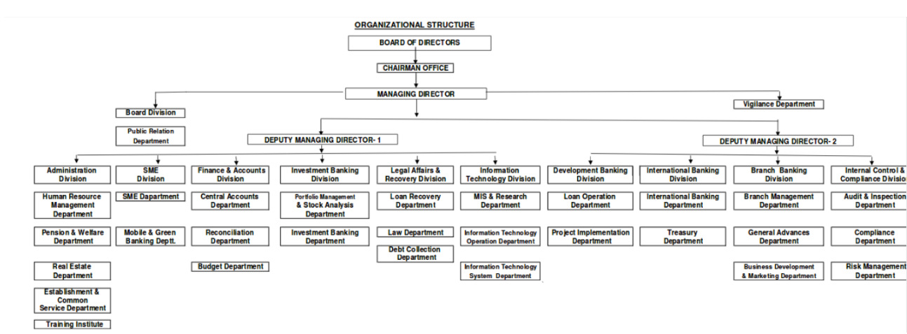

Figure : Organogram of BDBL

**Board of Directors**

While managers have the task of supervising everyday operations, the shareholders appoint a board of directors. The task of the board of directors is to keep an eye and govern the operations of the bank while safeguarding the assets of the shareholders. The responsibilities of the board member include selecting management, formulating goal and strategies, keeping a balance between business and caution, protecting stockholders, supervising audits and looking out for external and internal conflicts of interest.[1]

**Chairman Office**

Chairman is the highest officer. He is elected by the board to preside over meetings and conduct business in a disciplined manner. Managing Director, Board Division and Vigilance Department come after the chairman office in the organization hierarchy.

**Board Division**

Board division is responsible for arranging a meeting of the board of directors, executive committee, audit committee, annual general meeting, prepare and circulated decisions to the related bodies and take out implementation status of the board decision and apprise the same to the board. It is also responsible for approval of various issues of concern’s interest.

**Vigilance Department**

Functions of this department are-

* to formulate policy and take preventive measures to tackle fraud and forgery
* to handle inspection, inquiry, investigation into complaints of fraud and forgery and their disposal as instructed by MD.

**Managing Director**

The Managing Director is in charge of ensuring the full implementation of the policy of the bank and to make amendments when needed. The post holder is also responsible to ascertain that bank operations are geared towards the growth, profits and increasing shareholder return.

The operations of the Managing Director are difficult to handle alone. All bank divisions are thus split between two Deputy Managing Directors: Deputy Managing Director-1 and Deputy Managing Director-2.

**Deputy Managing Director-1**

Deputy Managing Director-1 is in charge of the following divisions.

* Administration Division
* SME Division
* Finance & Accounts Division
* Investment Banking Division
* Legal Affairs and Recovery Division
* Information Technology Division

**Administration Division**

The following departments fall under the administration division.

* Human Resource Management Department
* Pension & Welfare Department
* Real Estate Department
* Establishment & Common Service Department
* Training Institute

**SME Division**

The following departments fall under the SME division.

* SME Department
* Mobile & Green Banking Department

**Finance & Accounts Division**

The following departments fall under the Finance and Accounts Division.

* Central Accounts Department
* Reconciliation Department
* Budget Department

**Investment Banking Division**

The following departments fall under the Investment Banking Division.

* Portfolio Management & Stock Analysis Department
* Investment Banking Department

**Legal Affairs and Recovery Division**

The following departments fall under the Legal Affairs and Recovery Division.

* Loan Recovery Department
* Law Department
* Debt Collection Department

**Information Technology Division**

The following departments fall under the Information Technology Division.

* MIS & Research Department
* Information Technology Operation Department
* Information Technology System Department

**Deputy Managing Director-2**

Deputy Managing Director-2 is in charge of the following divisions.

* Development Banking Division
* International Banking Division
* Branch Banking Division
* International Control and Compliance Division

**Development Banking Division**

The following departments fall under the Development Banking Division.

* Loan Operation Department
* Project Implementation Department

**International Banking Division**

The following departments fall under the International Banking Division.

* International Banking Department
* Treasury Department

**Branch Banking Division**

The following departments fall under the International Banking Division.

* Branch Management Department
* General Advances Department
* Business Development & Marketing Department

**Internal Control & Compliance Division**

The following departments fall under the Internal Control & Compliance Division.

* Audit & Inspection Department
* Compliance Department
* Risk Management Department

Below we provide the summary of offices.

Table : Summary of offices

|  |  |
| --- | --- |
| Name of Office | Number of Offices |
| Chairman Office | 1 |
| Managing Director Office | 1 |
| Deputy Managing Director Office | 2 |
| Division | 11 |
| Department | 30 |
| Zone | 4 |
| Branch | 27 |
| Proposed Branch | 23 |

In the chart below we show the office-wise distribution of manpower.

Table : Distribution of manpower

|  |  |
| --- | --- |
| Office-wise Distribution of Manpower | |
| Head Office | 581 |
| Zone | 40 |
| Branch Office | 595 |
| Proposed 23 Branches (2018) | 253 |
| Total | 1469 |

## 2.3. SERVICES PROVIDED BY BDBL

In this part of the term paper we mention these services and elaborate on these. BDBL provides the following services to its customers.

* Online banking
* Automated Clearing House
* Electronic Fund Transfer System
* Account Opening
* New Cheque Book
* Lost Cheque Book
* Signature Card Change
* Address Change
* Account Close
* Demand Draft Issue
* Payment Order Issue
* Selling of Prize Bond
* Selling of Savings Certificate

### 2.3.1. ONLINE BANKING

BDBL offers online banking through all 43 branches. Any customer will be able to get the following services online.

* Cash withdrawal
* Cash deposit

### 2.3.2. AUTOMATED CLEARING HOUSE

All cheque & instrument-based inter-bank transaction now take place through the BACH.

The BACH has two components.

* Bangladesh Automated Cheque Processing System (BACPS)
* Bangladesh Electronic Funds Transfer Network (BEFTN)

The clients of BDBL are availing themselves of modern banking facilities with the help of these services.

### 2.3.3. ELECTRONIC FUND TRANSFER SYSTEM

BEFTN (Bangladesh Electronic Fund Transfer Network) is used for this purpose.

### 2.3.4. ACCOUNT OPENING

BDBL as per customer’s accepted policy being prepared by BB’s instruction opens various types of customer accounts.

### 2.3.5. NEW CHEQUE BOOK

MICR is a process of printing cheques using magnetic ink and special fonts to create machine-readable information. It is the first step towards electronic cheque clearing process.

The new MICR coded cheque book will facilitate:

* Quick processing and faster cheque clearing time
* Prevent cheque related fraudulent activities

### 2.3.6. LOST CHEQUE BOOK

Submitting an application in the prescribed proforma with a copy of GD entry form at the local police station will allow the issuance of a duplicate of a lost cheque book.

### 2.3.7. SIGNATURE CARD CHANGE

Bank changes the specimen signature card whether and customer resigns/dies/declared disabled and alike these to be a bona-fide client.

### 2.3.8. ADDRESS CHANGE

If any account holder changes his address, he has to inform the bank immediately.

### 2.3.9. ACCOUNT CLOSE

A customer can close their account anytime. For this the bank is to be notified or an Account Closure form needs to be submitted. The form is to be submitted to the branch where the account was opened.

### 2.3.10. Demand Draft Issue

A Demand Draft is a negotiable instrument issued by a bank/branch in favor of client directing another bank or its own branch to make payment of a certain amount to the specified party.

### 2.3.11. Payment Order Issue

A payment order is a financial instrument that embodies a mode a payment which is to clear in the very specific branch of the bank that issued it.

### 2.3.12. Selling of Prize Bond

Selling of prize bond is to sale out of a government instrument to gram people’s money.

### 2.3.13. Selling of Savings Certificate

Selling of savings certification is to sale or release of government savings certificate to gather public money/funds. It is a public debt mechanism.

# CHAPTER 3: INFORMATION SYSTEM OF BDBL AND THE CHALLENGES

In this chapter, we give our full attention to the Information System of BDBL and the challenges faced while implementing the Information System.

## 3.1. INFORMATION SYSTEMS

A system is a set of interrelated components which work together with the aim of reaching a common goal. It accepts inputs, transforms the inputted data and gives output.

An information system consists of people, hardware, software, data and network components. Information system uses all these resources for converting disorganized data into desired information.

Information systems are crucial for the smooth operation of organizations nowadays. Financial Institutions like BDBL are no exception to this general rule. Below we mention information systems which are used by BDBL.

## 3.1.1. CORE BANKING SOLUTION (CBS)

CORE stands for ‘Centralized Online Real-Time Exchange’. CORE Banking Solutions is a centralized information system which enables customers to conduct their bank-related activities no matter what branch [2]. It eradicates the obstacles of geo-specific banking activities.

The CBS assists the bank for the following functions.

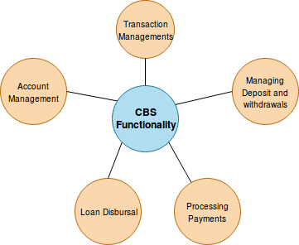

Figure 2: Functionalities of CBS

* Transaction Managements
* Managing Deposits and Withdrawals
* Processing Payments in the form of cash, cheques, mandates etc
* Loan disbursal
* Account Management

To perform different sorts of transactions, two types of users are necessary. These are MAKER and CHECKER. Also, to limit unauthorized access, the CBS implements a transaction limit based on the type of user.

The Core Banking Solution service is available online for all branches of BDBL. To monitor Core Banking Solution activities, there is an audit trail.

### 3.1.2. AUTOMATED CHEQUE PROCESSING SYSTEM

Automated Cheque Processing (ACP) is a process that allows for faster cheque clearing [16]. Paper cheques used to be processed manually, a process that took up to seven days to clear. With ACP, deposited cheques are cleared by the end of the next day if deposited by 2:00 PM. In BDBL automated cheque processing takes help of BACH. Payment division, benefits and parts of BACH are given in the figures below:

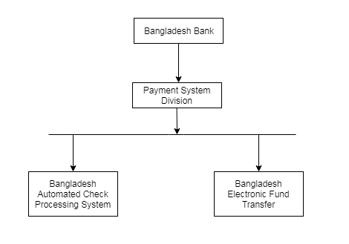

Figure 3: Payment division

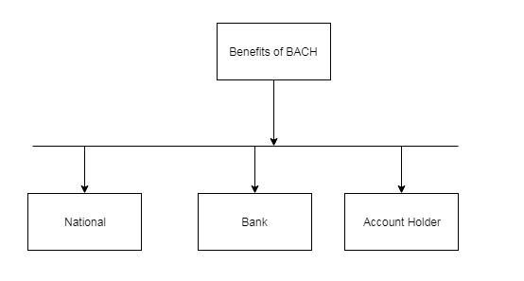

Figure 4: Benefits of BACH

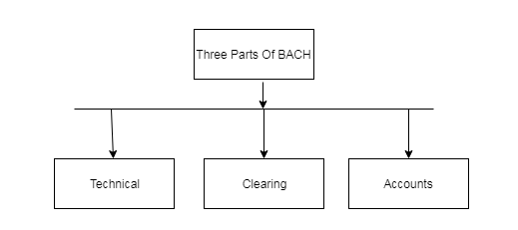

Figure 5: Parts of BACH

Characteristics of MICR Cheque

* MICR stands for Magnetic Ink Character Recognition.
* Clearing Bank Specification-1
* Cheque size- 7.5*3.5
* Cheque security-
* Watermark
* Microprint
* magnetic ink
* erasable ink
* invisible UV fluorescent
* chemical sensitivity

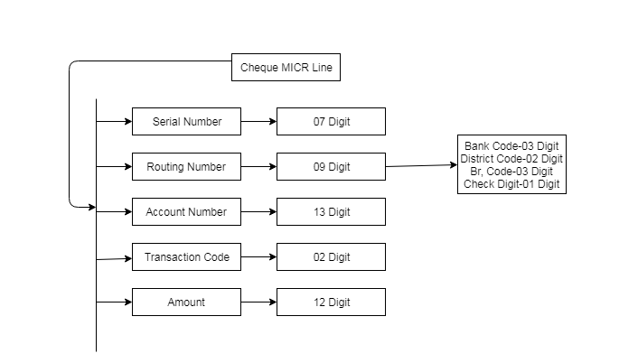

Figure 6: MICR line

There are two types of cheque processes-

* Inward process
* Outward process

Inward Clearing

* Download cheque from PBM
* Read Cheque
* Process Cheque(debit from a/c Holder)
* Cheque-Honour or Dishonour
* Return-Dishonour Cheque(ORE)

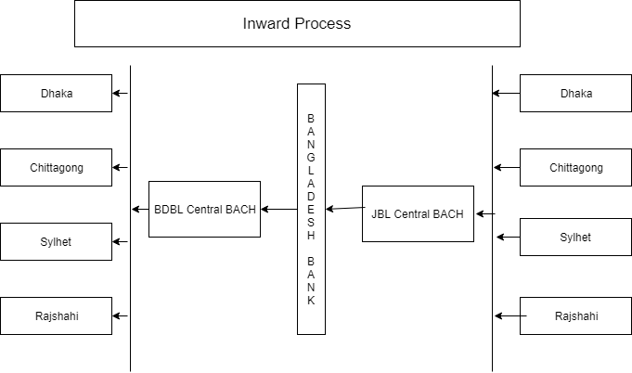

Figure 7: Inward clearing process

Outward clearing

* Scan cheque
* Prepare for outward cheque
* Edit
* Maker
* Checker
* Verifier
* Outward presentation
* Download-inward return cheque

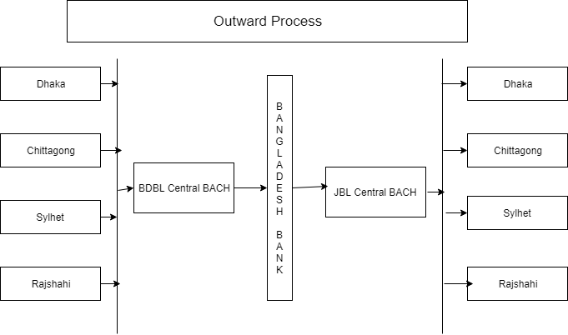

Figure 8: Outward clearing process

### 3.1.3. ELECTRONIC FUND TRANSFER (EFT)

EFT stands for Electronic Fund Transfer. It is a transaction that happens over a computerized network. It can involve accounts at the same financial institution or different ones. The goal of electronic fund transfer is to reduce the paper-based payment methods and make the transaction procedure faster and cost-effective [15].

BDBL makes use of EFT for the transaction of data within the national border.

### 3.1.4. REAL TIME GROSS SETTLEMENT (RTGS)

Real Time Gross Settlement System is a system where the transfer of funds takes place from the account of one bank to another bank on a real-time and gross basis. Real-time transactions to do not require any waiting period i.e. they can be conducted instantly. Scores are settled as soon as these are executed.

### 3.1.5. FOREIGN REMITTANCE SYSTEM – XPRESS MONEY

According to Investopedia, “Foreign remittance is a transfer of money from a foreign worker to their family or other individuals in their home countries.” BDBL makes use of the well-known platform, Xpress Money. Xpress money makes use of unique 16 digit XPIN which provides better money transfer experience. It provides a number of services related to the reception of money like cash transfer, bank account, mobile money and door delivery [3].

### 3.1.6. SWIFT

The messaging services of SWIFT were initiated in 1977.Since then it was widely used by banks to communicate instructions related to cross-border transfers. The service remains as relevant serves as the primary communications channel for financial institutions engaged in correspondent banking all around the world. The message services are acknowledged to be secure, cost-effective and reliable. The use of standardized messages and reference data ensures that data exchanged between institutions is unambiguous and machine friendly, facilitating automation, reducing costs and mitigating risks. Through SWIFT, banks, custodians, investment institutions, central banks, market infrastructures and corporate clients, can connect with one another exchanging structured electronic messages to perform common business processes, such as making payments or settling trades [5].

SWIFT is committed to the confidentiality, integrity and availability of its messaging services. It claims to have controls and procedures in place to: protect message data from unauthorized disclosure; to help ensure the accuracy, completeness and validity of messages and their delivery; and to ensure our service availability requirements are met.

BDBL makes use of SWIFT system for Cross-Border Funds Transfer. Letters of Credit and related financial messages are crucial to banks and clients. SWIFT is reliable to safeguard the crucial information from intruders.

### 3.1.7. ENTERPRISE RESOURCE PLANNING

BDBL has some custom-made Enterprise Resource Planning Software which is being used in its headquarters. All the ERP software are used for the following purposes.

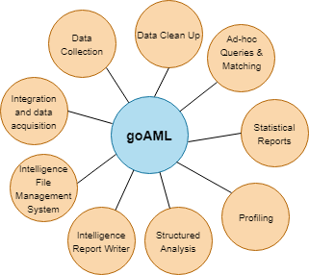

Figure : Enterprise resource planning

* Payroll
* Provident Fund Management
* Pension Management
* Investment Management

### 3.1.8. ONLINE REPORTING SYSTEMS

Some Online Reporting Systems are prevalent in BDBL. Below we mention the names of these online reporting systems.

* goAML of Bangladesh Bank
* ISS
* Foreign Accounts Tax Compliance Act (FATCA)

**3.1.8.1 goAML**

Terrorist financing and money-laundering are major threats to financial institutions as they hamper the security and regularity of financial institutions. goAML is a solution provided by the United Nations Office on Drugs and Crime. It was designed to be used by Financial Intelligence Units. goAML has the following features [10].

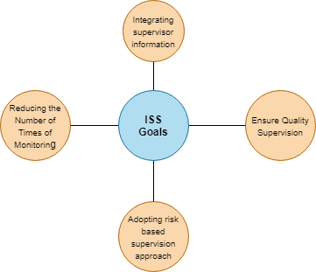

Figure 10: Features of goAML

* Data Collection
* Data Clean Up
* Ad-hoc Queries and matching
* Statistical reports
* Profiling
* Structured Analysis
* Intelligence report writer
* Intelligence File Management System
* Integration and/or data acquisition

**3.1.8.2. ISS**

ISS stands for Integration Supervision System. It is a web-based monitoring tool. Its task is to integrate the existing multifold supervision mechanism of Bangladesh. Below we state the goals of ISS [11].

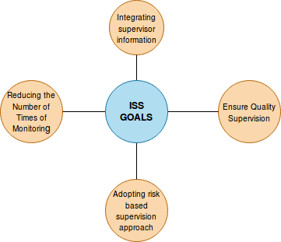

Figure : ISS Goals

* Integrating supervision Information
* Ensuring quality supervision
* Adopting risk-based supervision approach
* Reducing the number of times of monitoring

**3.1.8.3. FOREIGN ACCOUNTS TAX COMPLIANCE ACT (FATCA)**

According to IRS, “The Foreign Account Tax Compliance Act (FATCA) generally requires that foreign financial Institutions and certain other non-financial foreign entities report on the foreign assets held by their U.S. account holders or be subject to withholding on withholdable payments.” FATCA emerged from the HIRE Act [12].  The original act included legislation requiring U.S. individuals to report about their foreign financial accounts and foreign assets depending on their value.

### 3.1.9. EMAIL SERVICE

BDBL has its own domain based email service. Its bandwidth is 15MB.

### 3.1.10. BDBL FILE TRANSFER SYSTEM (BFTS)

BFTS stands for BDBL File Transfer System. It is an alternative to mailing. Through the BDBL File Transfer Systems, data and files can be exchanged between branches.

### 3.1.11 eScan ANTIVIRUS

Firewall safeguards the system from most of the vulnerabilities. However, firewall has its loopholes. There exist some threats that can pass the firewall unnoticed because it was part of a mail attachment or some other reason. For this purpose, experts recommend an additional security to protect devices. These additional layers are called anti-virus [6].

Financial Institutions like BDBL are at a greater risk of unauthorized accesses. BDBL uses eScan Antivirus (corporate version) for protecting its systems. The expected task of the antivirus is as follows.

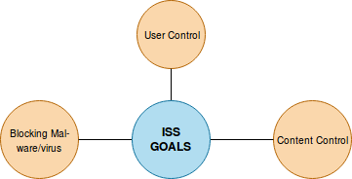

Figure : Task of eScan Antivirus

* User control
* Content control
* Blocking malware/virus

eScan platform claims to provide the following services.

* Endpoint Security
* Low Memory Usage
* FREE eScan Remote Support
* White-listing
* Malware URL Filter
* Comprehensive Protection with Virtual Keyboard
* Protection from accidental detections of Operating System files (false-positives)
* Auto-detection of gaming mode
* OS vulnerability checks
* Auto and free feature addition during the period of contract
* Auto-backup of critical files
* Windows Based eScan Rescue Disk
* Works in Safe Mode
* Customization

### 3.1.12. IPSec VPN

IPSec stands for Internet Protocol Security. VPN stands for Virtual Private Network. Internet Protocol Security (IPsec) VPN refers to the process of creating and managing VPN connections or services using an IPsec protocol suite. It is a secure means of creating VPN that adds IPsec bundled security features to VPN network packets. IPsec VPN is also known as VPN over IPsec.

BDBL makes use of IPSec VPN for Core Banking Solutions.

Techopedia explains Internet Protocol Security VPN (IPsec VPN) in the following way.

*“*IPsec primarily utilizes tunnel mode for creating VPN tunnels. IPsec provides an enhanced level of security on VPN connections by default by providing authentication, encryption and compression services at the network level of VPN. This is achieved through the encapsulated security payload (ESP), authentication header (AH) and IP payload compression (IPComp) protocol. For each outgoing IP packet, it is encapsulated and secured using the IPsec packet” [7].

### 3.1.13. SMS SERVICES

BDBL has a dedicated SMS Service which keeps customers notified of all of their account activities. The following services are prevalent at the moment.

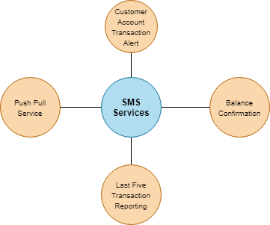

Figure : SMS Services

* Alert System Service for Customer Accounts Transaction
* Balance Confirmation
* Last Five Transaction Reporting
* Push Pull Service

### 3.1.14. ORACLE DATABASE

Oracle Database is more commonly known as Oracle. It is a multi-model database management system produced and marketed by Oracle Corporation.



Figure : Oracle Database

The database is widely used for the operations [8].

* Online Transaction Processing
* Data Warehousing
* Mixed Database Workload

For the purpose of storing the huge chunk of data, BDBN uses Oracle Database Version 11G. 11G has the following features.

* Active Data Guard
* Secure Files
* Exadata

### 3.1.15. MICROSOFT EXCHANGE SERVER

The main server is needed to be configured. Verification is also needed. They do not have a strong backup. They are trying to solve this problem. They are thinking to buy some backup servers so that all data can be retrieved if any server gets down.

### 3.1.16. SSL

SSL stands for Security Socket Layer.

According to Digicert [ 9], When a browser tries to access a website which is secured by SSL, the browser and the web server build an SSL connection. The incident is termed as an “SSL Handshake”. The handshake takes place at one and is invisible to the user.

An SSL connection requires three keys in order to be set up: public, private and session keys.

The encryption of a public key can only be decrypted by the corresponding private key. Encryption and decryption consume a huge amount of processing power. For this purpose, these keys are only used during the SSL Handshake. The objective is to create a symmetric session key. After the secure connection is made, the session key is used to encrypt all transmitted data.

BDBL has integrated SSL in their system to protect data.

### 3.1.17. EXCHANGE ONLINE PROTECTION (EOP)

Exchange Online Protection is a hosted e-mail security service. The service is owned by Microsoft. The primary objective of Exchange Online Protection is mentioned as follows.

* Filtering spam
* Removal of computer viruses from e-mail messages

BDBL uses EOP services to maintain email security.

## 3.2. THE CHALLENGES

The challenges encountered by BDBL when implementing the information systems are stated as follows.

**Single Connection between Head Office and Branch**

In ideal situations, there would be multiple connections between head office and a branch. Having multiple connections reduces the chance of becoming disconnected and losing in case of failure. BDBL is facing a challenging atmosphere because of the existence of a single connection between the headquarters and a branch.

**Lack of Firewall**

While antivirus software helps to protect the file system of a device, a firewall, in most cases, has the ability to prevent that intrusion in the first place. Firewalls can monitor network traffic and can block undesired traffic. Not having a firewall puts BDBL at a risk of going under the siege of perpetrators. The damage a single perpetrator can cause on a financial institute cannot be limited by terming it as “massive”.

**Poor Condition of Data Center**

Data center is a space or building which serves the purpose of housing computers and associated machineries. BDBL being a state-owned commercial financial institution has been running on manual banking procedures until recently. It is running several projects for digitalizing the overall banking procedure. For this, the condition of data centers is not as good as commercial banks run by private organizations. BDBL has plans of purchasing more powerful servers and establishing SAN (Storage Area Network).

**Lack of Manpower Specialized in Information Technology**

As mentioned before that BDBL has embraced the use of technology very recently. Thus it lacks manpower who expertise in the use of technology. The recruitment procedure is also an impediment in recruiting a batch of skilled persons. The deficit stands in the way of approaching the challenges of implementing information systems.

**Insufficient Data Recovery Precautions**

BDBL has just one data center till date. It is located in Karwan Bazar, Dhaka. To sum up the problem of just one data center, the existing data center is not yet complete. It just exists for compliance. In case of natural disaster, the collapse of building, fire incident or any other disaster that can cause the destruction of the data center would mean an unrecoverable loss of data.

An ideal plan would be to have multiple data centers at different geo-locations with several copies of the same data. Recently, BDBL has established plans to build a ten-floor data center near Khulna as it less prone to earthquakes.

**Database and Network Administrator with No Business Background**

Ideal situations demand a Database Administrator to have no knowledge about business. The general perception is that being clueless of business schemes would de-motivate an individual to take risks for personal financial gain. BDBL, however, has no separate professional.

**Absence of Independent Security Department**

BDBL has no separate Information Security team to keep up the system defenses. However, they have stated they are in the process of recruiting.

**Absence of Independent Audit Team**

BDBL has no separate Auditing Team. Thus risk assessments in the information system are not conducted properly.

**Absence of Syslog Server**

Syslog, which is a standard protocol, stands for System Logging Protocol. The protocol is used for sending system log or event messages to a specific server, a syslog server. The protocol is enabled on most network equipment such as routers, switches, firewalls, and even some printers and scanners. It is mainly used to gather several device logs from different machines in a central location. The purpose of collecting of device logs is to monitoring and reviewing activities [13].

BDBL has no implementation of syslog server till today. Thus monitoring and locating a missed record becomes quite a hassle.

**Absence of AAA Server**

AAA in AAA server stands for authentication, authorization and accounting services. The AAA server is dedicated for handling user requests for [access](https://whatis.techtarget.com/definition/access) to computer resources. It provides authentication, authorization and accounting services for an enterprise. BDBL has no AAA server. Thus an authorized person can gain access to the system and perform actions it has virtually no authorization over. Accounts can be manipulated and money may get leaked.

**System Vulnerability**

A secure system is a reflection of the CIA triad. CIA stands for Confidentiality, Integrity and Availability. It is a model that serves as a guide of information security within an organization. Confidentiality is the set of principles that places a barricade on access to information. Integrity is the assurance that the information is reliable and correct. Availability represents reliable access to the information by the authorized party [14].

BDBL has stated that their information systems are deficit in the CIA criteria.

**No Existence of Active Directory**

An active Directory is a software developed by Microsoft. As stated by the Intermedia Team. Information Technology Administrator makes use of Active Directory to organize the hierarchy of the computers in an organization i.e. which computers belong to which network, which users have access to a certain repository.

BDBL has plans of purchasing Active Directory to limit access to sensitive data and prevent spyware incidents.

**Absence of Maintenance Team**

BDBL has no maintenance team. Thus, bugs and problems of the existing information system remain unsolved for a long time.

**Display to Monitor Branch Services**

Currently, a display exists in the Information Systems Operation Room. It shows the up and down network connections between the head-office and remote branches. BDBL however plans to construct a display that will show all banking activities that are going on in the branches.

**Vendor Dependency**

If one becomes dependent to the goods or services provided by a certain (vendor) supplier such that the person is compelled to pay a huge sum of money for switching costs, the situation is called vendor dependency. BDBL is currently dependent on particular vendors. This exposes BDBL to the risk of the breach as they believe 27 percent of the breaches emerge from vendor disloyalty.

**Lack of Incident Response Team**

BDBL has never faced any data breaches because of its limited use of technology. Thus, there is no existence of an incident response team. They believe an incident response team would be necessary when they decide to include ATM facilities in their services.

**Limitation of CORE Banking Solutions**

For lack of storage, firewall and other security services, this bank cannot enjoy facilities of core banking solutions like ATM booth, mobile banking etc.

**Absence of Mobile Banking Opportunities**

BDBL does not have any mobile banking facility.

**Upgradation of SWIFT Alliance Access with Operating System and Server**

For lack of storage, firewall, weak database and other services, BDBL cannot internally upgrade SWIFT which is integrated to CBS. But when main company or vendor updates their software, Swift automatically gets updated.

**Upgradation of BACH**

Upgradation of BACH is on-going and soon it will be upgraded to BACH-II. System integration test is also going on.

**e-Library**

This section is almost completed and very soon it will be open to employees.

**e-Attendance**

Development of e-Attendance is at final stage and very soon it will be completed.

**Online Loan Application Submission System**

Work is on progress.

**Video Conferencing**

For video conferencing, BDBL uses skype and other applications. A conference room is used for this purpose. Some other facilities or software used for video conferencing will also be introduced very soon.

**Cyber Security Operation System**

BDBL does not have any cyber security operation system.

# CHAPTER 4: Conclusion

Information and Communication Technology (ICT) represents ample opportunities to introduce dramatic change in the developing world. The new technology provides new ways of communication between employees and customers in financial institution. Implementing information system confirms high level of service quality and effective information sharing between all departments in the bank. It also provides right information to the senior management inside the banks that help to make right decision.

This study concludes that the IT infrastructure of BDBL is not sufficient. A reason behind the deficit is the lack of skilled manpower. The recruitment procedure is responsible for this. Since the recruitment procedure of a government organization cannot be amended easily, the first recommendation this study would be to give the employees proper training about all the functionalities of information system. This will improve their experience and ability to deal with all the infrastructures. In addition to that the perception and willingness of managers in the bank is very important to ensure rapid implementation of Management Information Systems as solutions. Moreover, before BDBL fully implements its online system, it needs to have its data warehouse constructed, preferably more than one. Replica of data needs to be stored so that in event of collapse of a data center/server, data will not be lost. A syslog server needs to be built to keep track of all system events. BDBL needs to recruit specialized IT professionals for maintaining the infrastructure of the information system as well as an incident response team and security team to protect the data and the system. It is urgent that it take initiatives to build a firewall as early as possible. Because portable devices like smartphones are more in vogue, BDBL should launch mobile services. This would give the target customers, mostly businessmen and industrialists a better user experience and motivate the customers to work with the state operated bank. A future recommendation for BDBL would be to make use of machine learning or deep learning to develop a system that would help BDBL in selecting loan applicants and identifying projects with great potential for the economic growth of Bangladesh.

# REFERENCES

1. URL: <https://careertrend.com/list-5954250-duties-responsibilities-board-directors-bank.html> ,Career Trend [last accessed on: October 2, 2018, at 7 PM]
2. URL: <https://www.nelito.com/blog/what-is-core-banking-solution.html> , nelito, [last accessed on: October 2, 2018 at 2 PM]
3. URL:<http://www.xpressmoney.com/our-philosophy.php>, EXPRESS MONEY, [last accessed on: October 1, 2018 at 3 PM]
4. URL:<https://www.investopedia.com/terms/f/foreign-remittance.asp>, INVESTOPEDIA, [last accessed on: October 5, 2018 PM at 4 PM]
5. URL: <https://www.swift.com/about-us>, SWIFT, [last accessed on: October 7, 2018 PM at 3 PM]
6. URL: <https://www.escanav.com/en/index.asp>, eScan, [last accessed on: October 7, 2018 PM at 4 PM]
7. URL: <https://www.techopedia.com/definition/30763/internet-protocol-security-vpn-ipsec-vpn>, techopedia, [last accessed on: October 8, 2018 PM at 2 PM]
8. Oracle, Multimodel Database with Oracle Database 12c Release 2, ORACLE WHITE PAPER | MARCH 2017
9. URL:<https://www.digicert.com/ssl/>, Digicert, [last accessed on: October 8, 2018 PM at 2 PM]
10. goAML chapter 3 section 1 <http://goaml.unodc.org/>, AML, [last accessed on: October 8, 2018 PM at 2 PM]
11. URL, <http://bankerslearninghouse.com/wp-content/uploads/2016/08/Presentation-on-ISS-fundamentals.pdf>, [last accessed on: October 8, 2018 PM at 2 PM]
12. URL:<https://www.irs.gov/businesses/corporations/foreign-account-tax-compliance-act-fatca>,IRS, [last accessed on: October 8, 2018 PM at 2 PM]
13. URL:<https://www.paessler.com/it-explained/syslog>, PAESSLER, [last accessed on: October 8, 2018 PM at 2 PM]
14. URL:<https://whatis.techtarget.com/definition/Confidentiality-integrity-and-availability-CIA>, confidentiality, integrity and availability(CIA triad), [last accessed on: October 8, 2018 PM at 2 PM]
15. D.A.Kumar, Bangladesh Electronic Funds Transfer Network, [10 August 2010]